

Hypermedia Applications a.y. 2018/19

Usability Evaluation Report 04/07/19

<http://www.pngp.it/>

**Alessandro Carughi – alessandro.carughi@mail.polimi.it**

**Luca Maltagliati – luca.maltagliati@mail.polimi.it**

**Marco Turetta – marco3.turetta@mail.polimi.it**

Abstract

The following document aims at resuming the results of the **Usability Study** conducted by our team for the evaluation of the following website <http://www.pngp.it/>.

The main **goal** of our report and of our study was to evaluate the website among this step:

1. **Inspection**;
2. **User Testing**;
3. **Reporting**: comparison of the results of the 2-evaluation process;

In the following we will illustrate and discuss the evaluation method adopted, along with the tools and instruments we used in order to accomplish our study.

Inspection

### About inspection report we first select which criteria is used for evaluating the heuristic score and then we done a table to report all this value to study which section of the site work well or not.

Finally, we report a short conclusion where we discuss the inspection result.

### **Definition of heuristic:**

* + **Navigation Heuristic:**
* Interaction consistency (H1): do pages of the same type have the same links and interaction capability?
* Group Navigation (H2): is it easy to navigate among group members and from a group introductory page to group members (and the other way around)?
* Structural Navigation (H3): is it easy to navigate among the semantic components of a topic?
* Semantic Navigation (H4): is it easy to navigate from a topic to a related one?
* Landmarks (H5): are landmarks useful to reach the key parts of the web site?
  + **Content**
* Information overload (H6): is the information in a page too much/too little?
  + **Layout**
* Text layout (H7): is the text readable?
* Interaction Placeholder (H8): are textual or visual labels of interactive elements “expressive” and they reflect the meaning of the interaction and its effects?
* Spatial Allocation (H9): is the on-screen allocation of contents and visual appropriate for their relevance?
* Consistency of page structure (H10): do pages of the same type have the same layout?

|  |  |  |  |  |
| --- | --- | --- | --- | --- |
| Category | Heuristic | Score | | Comment |
| Navigation | | | | |
|  | H1 | 4 | All the pages have the same header and the same footer | |
|  | H2 | 3 | It works fine, but the navigation is a little clunky, when the user goes to the internal pages there is not a back button that could be useful to keep track of the navigation | |
|  | H3 | 4 | Yes, because all the components of a topic are showed on the left side menu when a topic is open | |
|  | H4 | 3 | It easy to navigate from one topic to a related one, but it can be simpler if the pages contain more information | |
|  | H5 | 5 | Landmarks work well | |
| Content | | | | |
|  | H6 | 3 | Some pages could be aggregated, look H4 | |
| Layout | | | | |
|  | H7 | 3 | Is readable but there are too many texts and you can lose the point easily | |
|  | H8 | 2 | Nearly almost every button has the same form, so you have to read all the text to search where to go | |
|  | H9 | 3 | Some pages can be unified because there are too many buttons that can create confusion while surfing the website | |
|  | H10 | 4 | All the pages, excluded the index page, have the same layout | |

**H1**: All the pages, unless the index, have the same structure, so it easy to understand that all the link and interaction have the same capability.

**H2**: the website presents a “back button” that is not clearly defined, so, maybe, it’s not easy to return to the previous page unless by clicking the landmark correlated to it. This process could be annoying.

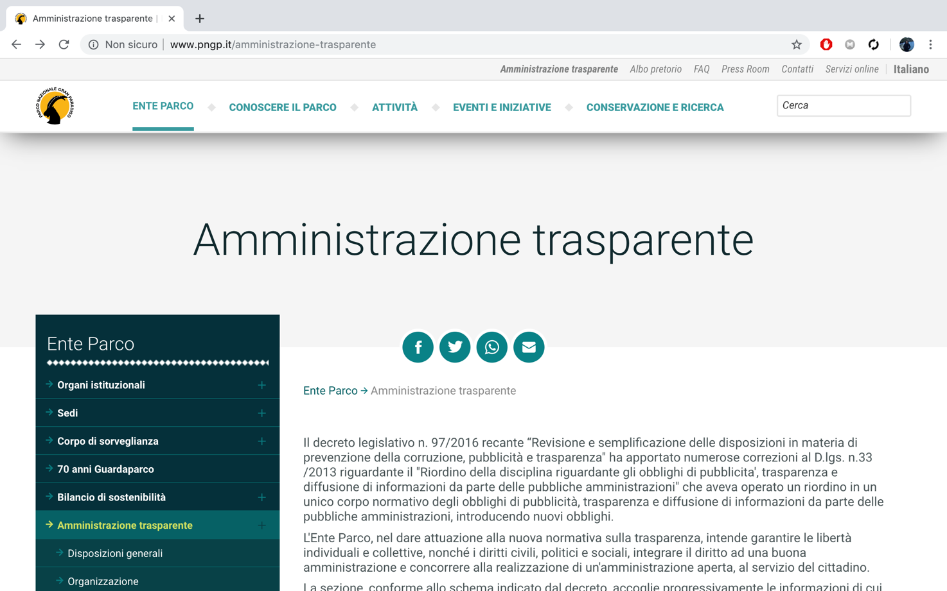

**H3**: The left side menu collocated in all pages is useful to reach all the components of a single topic

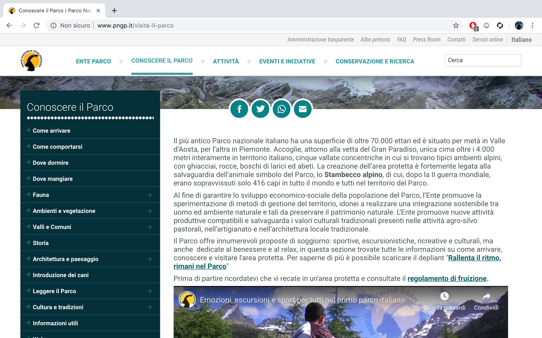

**H4**: Basically, it’s simple to navigate from one page to the one correlated, but it may be repetitive if a user wants to see all the information about a single topic, because he has to keep switching the page due to the less information written in some pages. For example, in the following screen we see that the “Ambienti e vegetazione” section could be summarized in only one page.

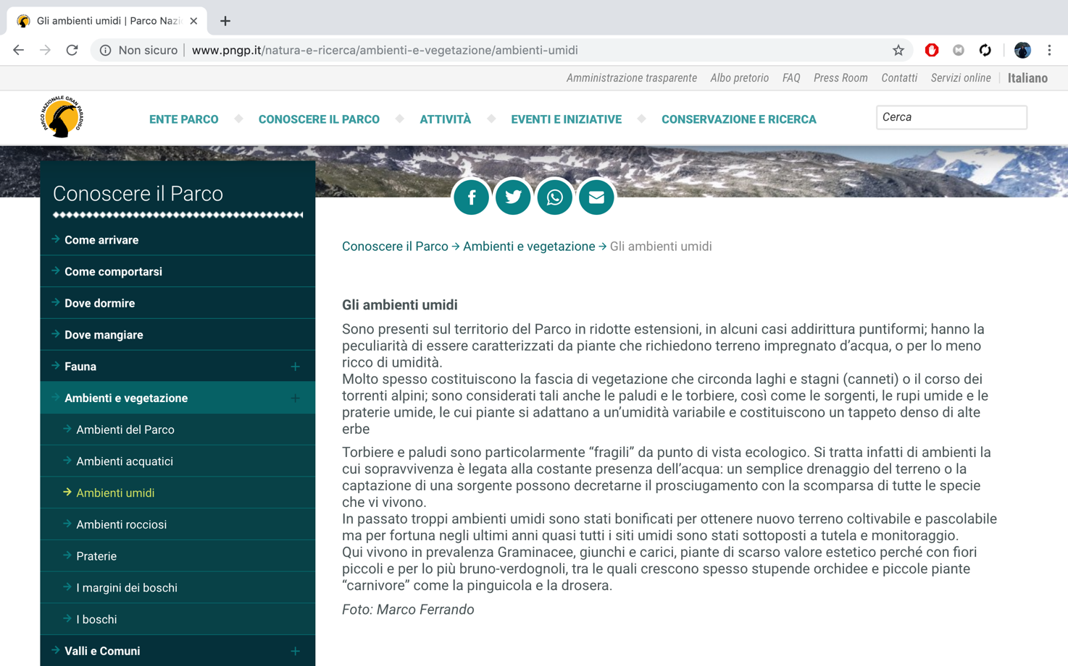

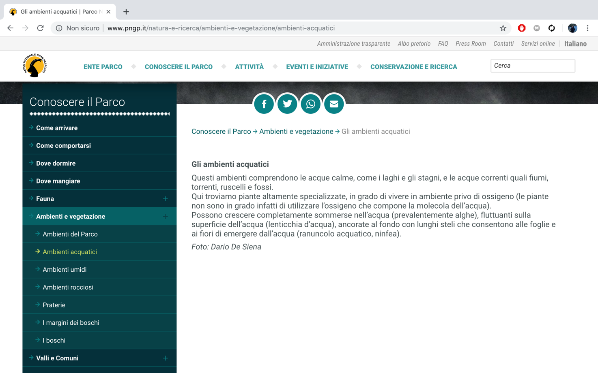

**H5**: The landmarks that are presented on the site are all useful to reach the key part of the website.

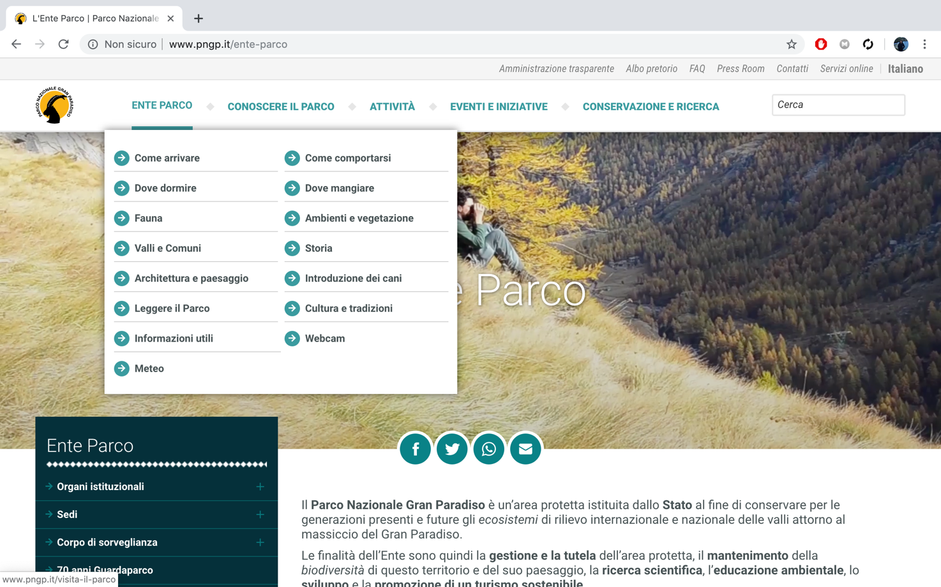

**H6**: See H3

**H7**: The text is readable but, in some pages, like the screenshots that are reported, there is too much text that can create a bit of confusion.

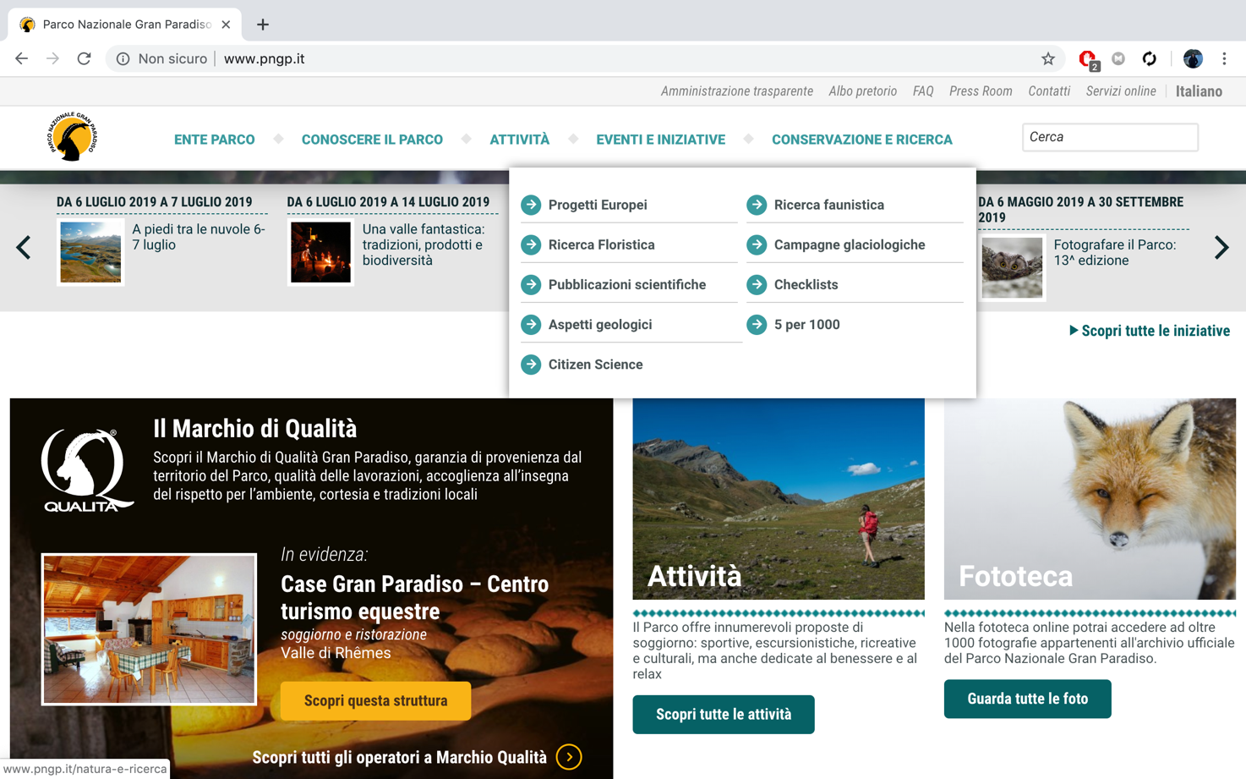

**H8**: Due to the similarity of all the button, you have to read all the text to search where to go.

**H9**:

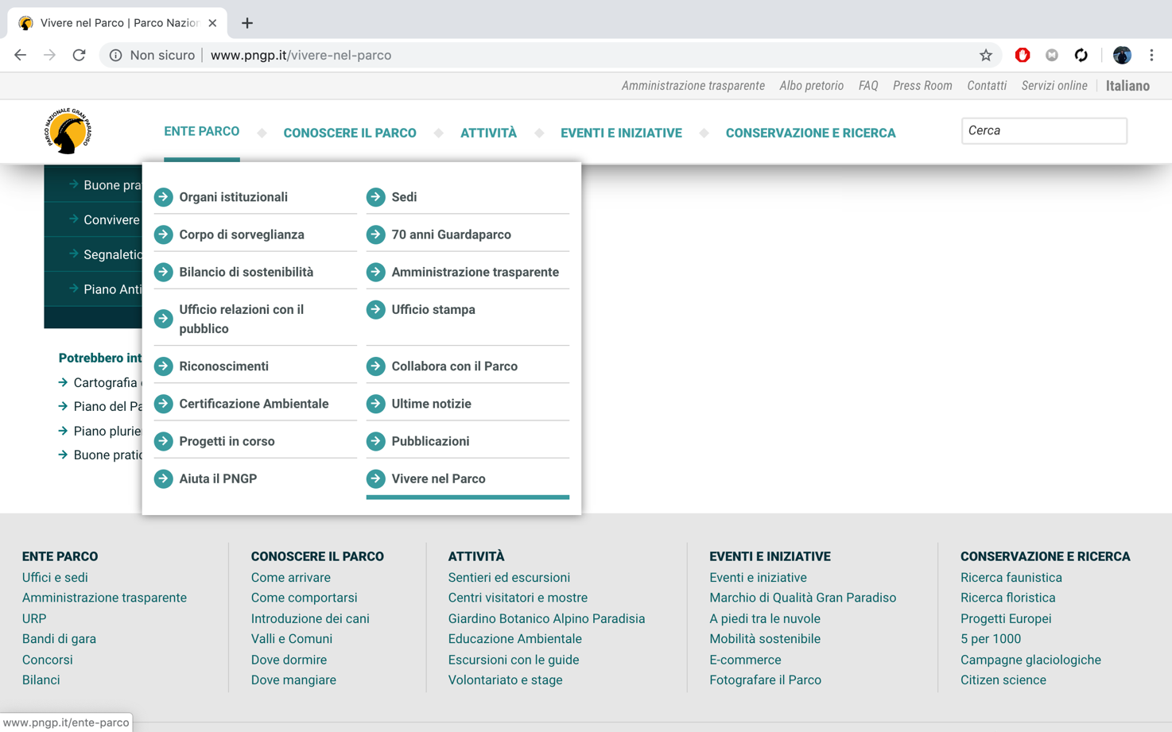

**H10**:

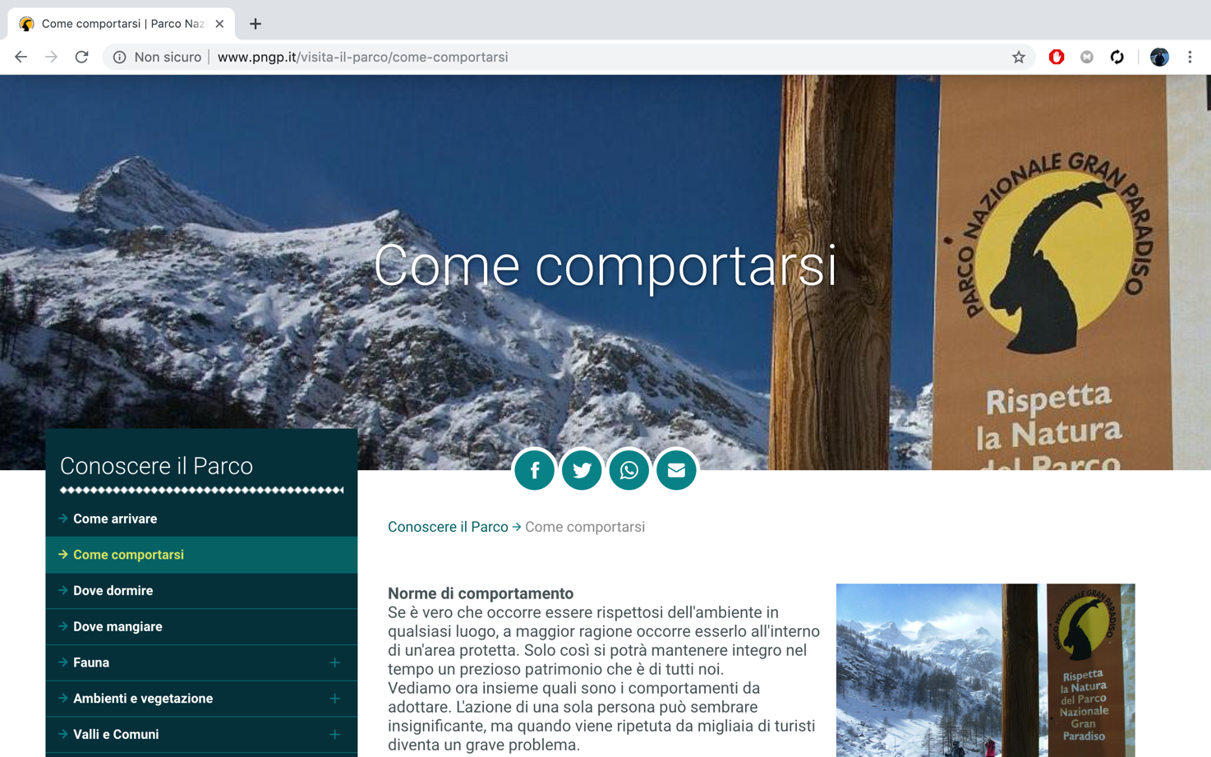

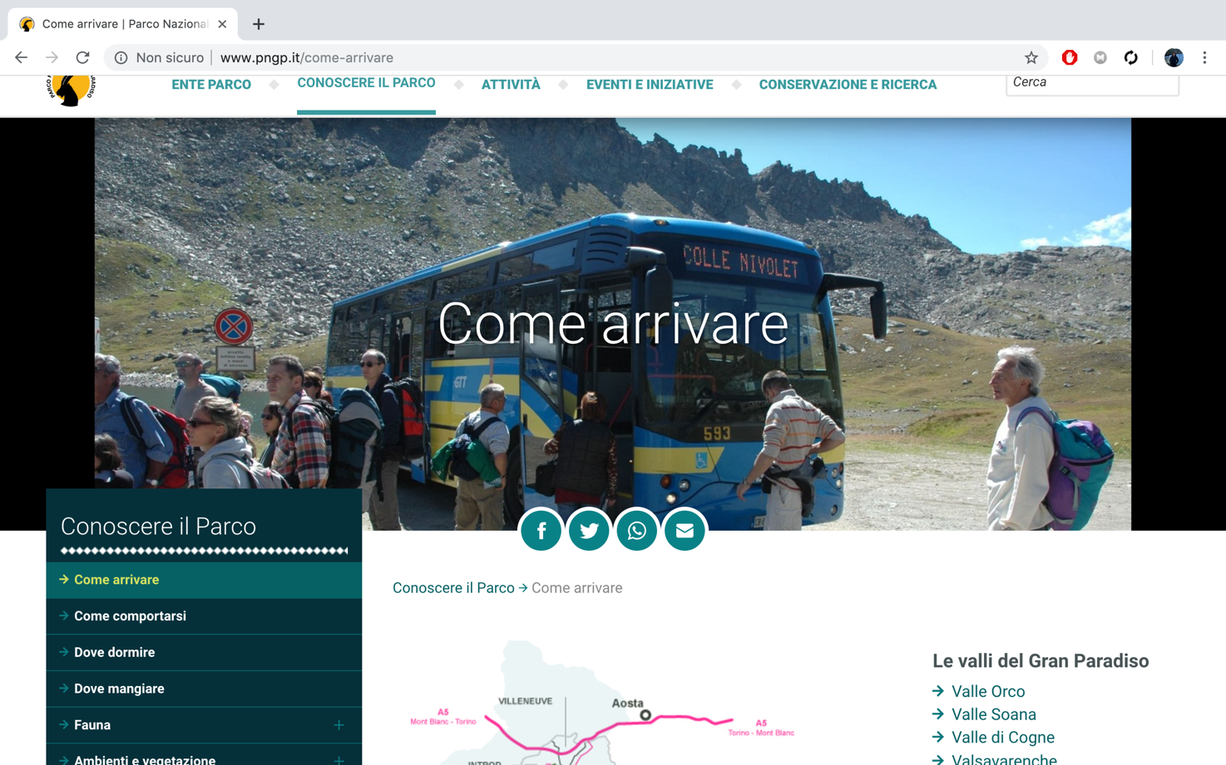

### **Data Analysis:**

### Here we provide the aggregated data of the heuristic evaluation.

**Total Heuristic Value:** 3,27

### **Conclusion:**

In conclusion the inspection test has shown us that the navigation on the web site is quite fine, but the content and the layout could be improved by simple changes.

Specifically, about the layout, the website could offer a major clarity of the pagination and the organization of the page, for example unify some pages that offer less, but similar information.

User testing

### **Design**

Goals:

1. To uncover actual difficulties that users have when interacting with the website
2. To obtain a systematic feedback on the effectiveness and efficiency of use of the website

In practice, we wanted to understand if the users could complete the tasks, how long could it take to accomplish the objective of the tasks, which difficulties were they facing and what was their consideration regarding the difficulty of these tasks.

Users and their profile:

We decided to perform the testing on 3 users and the profile selected was the on that corresponds to ‘young men’. By ‘young man’ we mean someone able to use technologies and confident while surfing the internet.

Measures:

Here we briefly describe the measures take in consideration both on the quantitative and the qualitative level.

Quantitative:

• Efficiency: here we mean time spent on the task

• Errors: wrong paths or actions, that the users perform

• Tasks difficulty: here we mean the users perceived difficulty

Qualitative:

* stops,
* frustrations,
* waiting periods,
* comments

On the qualitative level we considered stops, frustrations, waiting periods and wandering periods since they are easy to measure while observing the tester, but at the same time they give us a good feedback on the usability.

Tasks:

Task1:

You are going to gran paradiso. Find a trekking path.

Task2:

You would like to go to Gran Paradiso. Find the directions.

Task3:

You would like to go eat while visiting Gran Paradiso. Find if it is possible and where.

Recruitment:

Regarding the recruitment we chose our friend who were not attending computer science in university. This specification was meant to ensure we were choosing people of a young age and at the same time not too familiar with computer, but enough to perform a simple website visiting. The tasks were kept constant during the whole process of testing. Each of the users was really into visiting mountains site and trekking. This was an advantage because they were interested into the site.

Tools and technologies: we gave the users the possibility to use their own pc and their own network to perform the testing. We suggested them to use chrome as a browser, so that the compatibility was at the same level between all participants. Each of them respected the suggestions.

Data collection: We observed the users while they were visiting the website, taking notes on their actions. In addition, we explained how to “think aloud”, asking participants to think aloud during the observation, saying what comes to mind as they work. During the task we tracked the time on task and a the end we asked them few questions

Task assignment: we gave participants written instructions on the task

EXECUTION

Firstly we pretested our test to understand how well the tasks suited the case. In second instance, after modifying the tasks to our need, we tested the users in 3 different moments, separated from each other. It was done to not influence their behavior and to keep their performance as honest as possible. We let them choose the place where the test would have been done, making sure that we were present at that time. In addition, unconsciously, the chose the place that most suited the study system. Another plus of this consideration was to enhance the familiarity of the test as well as allowing us to observe closely the behavior of the users. To be more specific each of them choose the university as a place to perform the test, and they all chose the moment right after the lunch to be testers. We offered them the lunch as a way to repay them for their effort, making sure that they would perform happily the tasks. We collected the measurements manually. Data were gathered during the experience and not after it. One of use was every time the moderator, and the other two of us were the observers. We introduced the test to every users, briefly via email, and also the day of the test, more deeply. We let them use their PC to visit the website, and once, they started the tasks, we collected the measures, letting the tester finish.

SUCCESS RATE

|  |  |  |  |
| --- | --- | --- | --- |
|  | **TASK1** | **TASK2** | **TASK3** |
| **USER1** | **S** | **S** | **S** |
| **USER2** | **S** | **F** | **S** |
| **USER3** | **F** | **S** | **S** |

Success Rate: 7/9 = 78%

Regarding the success rate we weighted the success 1 and the failure 0, no one performed a partial success. In particular, they failed because of the 3 strikes rules, getting the wrong path 3 times in a row.

|  |  |  |  |  |  |  |
| --- | --- | --- | --- | --- | --- | --- |
|  |  | **Participants** | | | | |
| **TASK:** |  | **1** | **2** | **3** | **4** | **5** |
| **1** | *Task Time:*  *Min:sec* | 2 | 1:30 | 1:45 |  |  |
| *Completed?* | YES | YES | YES |  |  |
| **2** | *Task Time:*  *Min:sec* | 1:30 | 2:00 | 2:00 |  |  |
| *Completed?* | YES | NO | YES |  |  |
| **3** | *Task Time:*  *Min:sec* | 2:30 | 1:00 | 1:30 |  |  |
|  | *Completed?* | NO | YES | YES |  |  |

Time-on-task:

We calculated the time spent on the tasks for each participant. None of them took much time when performing the tasks because they were easy, when they failed they failed fast. We intended to consider also network delays, but none of them was having network troubles. The site was also fully supported by the browser, so there were no problems in this sense. On average, each participant took 2 minutes for the first task 1.30 minutes for the second task and 1.45 minutes for the third task. These were the times recorded not taking into consideration the failures or the successes. In particular the average failure time was 2.15 minutes and the success time was 1.50 minutes. We could aggregate all times because all the tasks were similar since the website is mostly an information gathering platform and most of the tasks you can perform on the website are under the category ‘information retrieval’.

Post-task questionnaire:

Regarding the post-task questionnaire we used the System Usability Scale, weighting the answers from 1 (strongly disagree) to 5 (strongly agree). We printed the questionnaire and we averaged the results between all participants for each question. 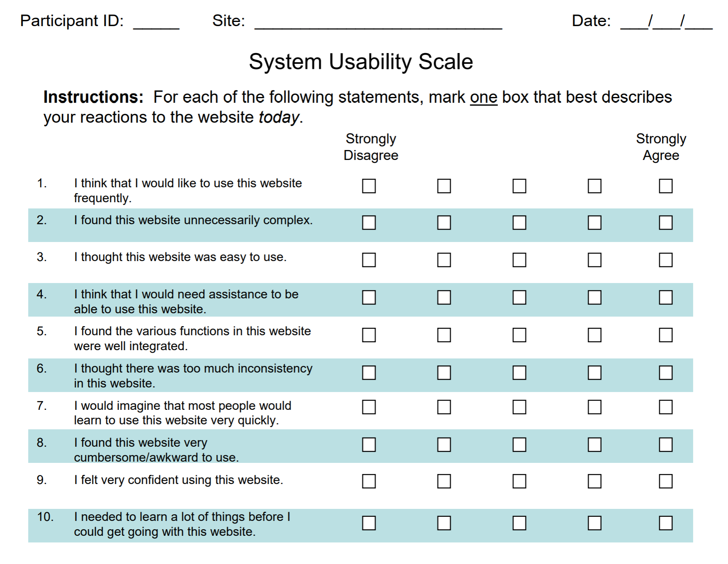

Average results

Question 1: 4

Question 2: 4.15

Question 3: 3.25

Question 4: 2.25

Question 5: 2.65

Question 6: 2

Question 7: 3.9

Question 8: 2.1

Question 9: 2.15

Question 10: 2

Each of the participants added comments regarding the poor user interface and that there were too many things in the menus.

OUTPUT

From the data collected we have seen that the site was not so complex to use but that the user interface and the content distribution could lead to mistakes. It was not complex because, despite the poor graphics, it has a lot of links and a lot of ways to reach a target point. It means that it is Efficient. This conclusion is very well sustained by the measured times. The Errors were caused by the poor graphics as well as by the possibility of reaching the website by multiple landmarks, which can lead to paths mistakes. Thus, we concluded that there should be an intervention on the user interface with priority 2(needed but not urgent) and also a content reorganization with priority2 (needed but not urgent).

Reporting

**Comparisons** of the results the 2 evaluation process